Cher Prazak

Eric Williams

WR417

Term Project

Turbidity Measurements

**Summary**

For this project, we will be discussing sediment transport and how it is measured and analyzed. For this, we will be looking at turbidity sensors placed in the Environmental Learning Center (ELC) which is measured in units of NTU (Nephelometric Turbidity Units). Turbidity is defined as how clear a liquid is or the amount of suspended sediment such as clay/silt, organic matter, algae, etc. Turbidity is important to monitor as it is key to knowing the quality of a stream for drinking water. In a stream that is more turbid or has more sediment in it, the quality is likely to be on the lower side. This is due to the increased amounts of sediment covering the habitat of macroinvertebrates and other aquatic beings. Pollutants and bacteria are also able to latch on to the suspended sediments which can be very bad if you are using this water for your drinking water. The way turbidity is measured is by shining a light through the water and recording how much light is reflected back. We will be using this method for the project with a turbidity sensor placed in the ELC in Fort Collins, CO and will be showing you how to read the sensor to get the data you want.

**Overall Learning Objectives**

At the end of this module, students should know how to visually recognize a stream as having high or low turbidity. They should also know how to find a good location for the equipment and then install the turbidity sensor and make sure it is recording. Once you are ready to collect your data, students should know how to work with the equipment to successfully connect to the device via bluetooth and download all of the recorded data onto a field laptop. Lastly, students should know how to interpret the data by making tables and figures.

**Measurement details**

The Ross Lab and many other water quality analysts use AquaTroll (AT) 600 and AquaTroll 500 water quality sondes manufactured by In-Situ, Inc. to measure turbidity and other water quality parameters. One of the best ways to measure turbidity data is by installing one of these sensors in a river that is deep enough to soak the sensor in water long-term (multiple months).

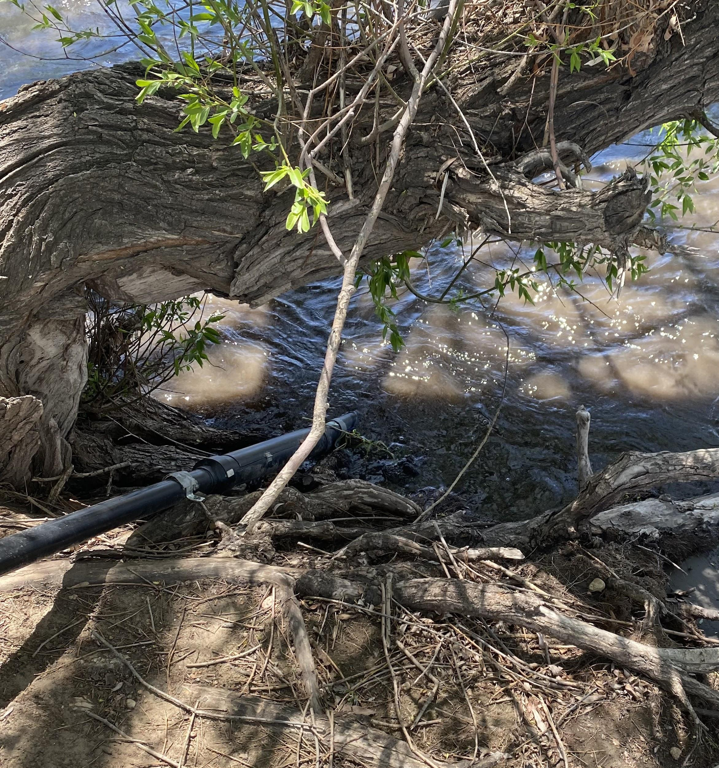

Figure 1. Example of AquaTroll Sonde Installation Apparatus. Picture credits to Eric Williams.

These sensors need to be housed in rigid tubing such as 2-3 inch diameter PVC pipes to protect them from being inundated by sediment or damaged by debris (Figure 1). The installation apparatus must also be anchored to the streambed and riverbank to prevent it from being swept downstream. The most common and reliable way to do this is by attaching the installation apparatus to a bridge over a stream, allowing easy access for technicians and preventing issues like the river eroding the streambank a sensor is anchored to away. However, setups like Figure 1 can work.

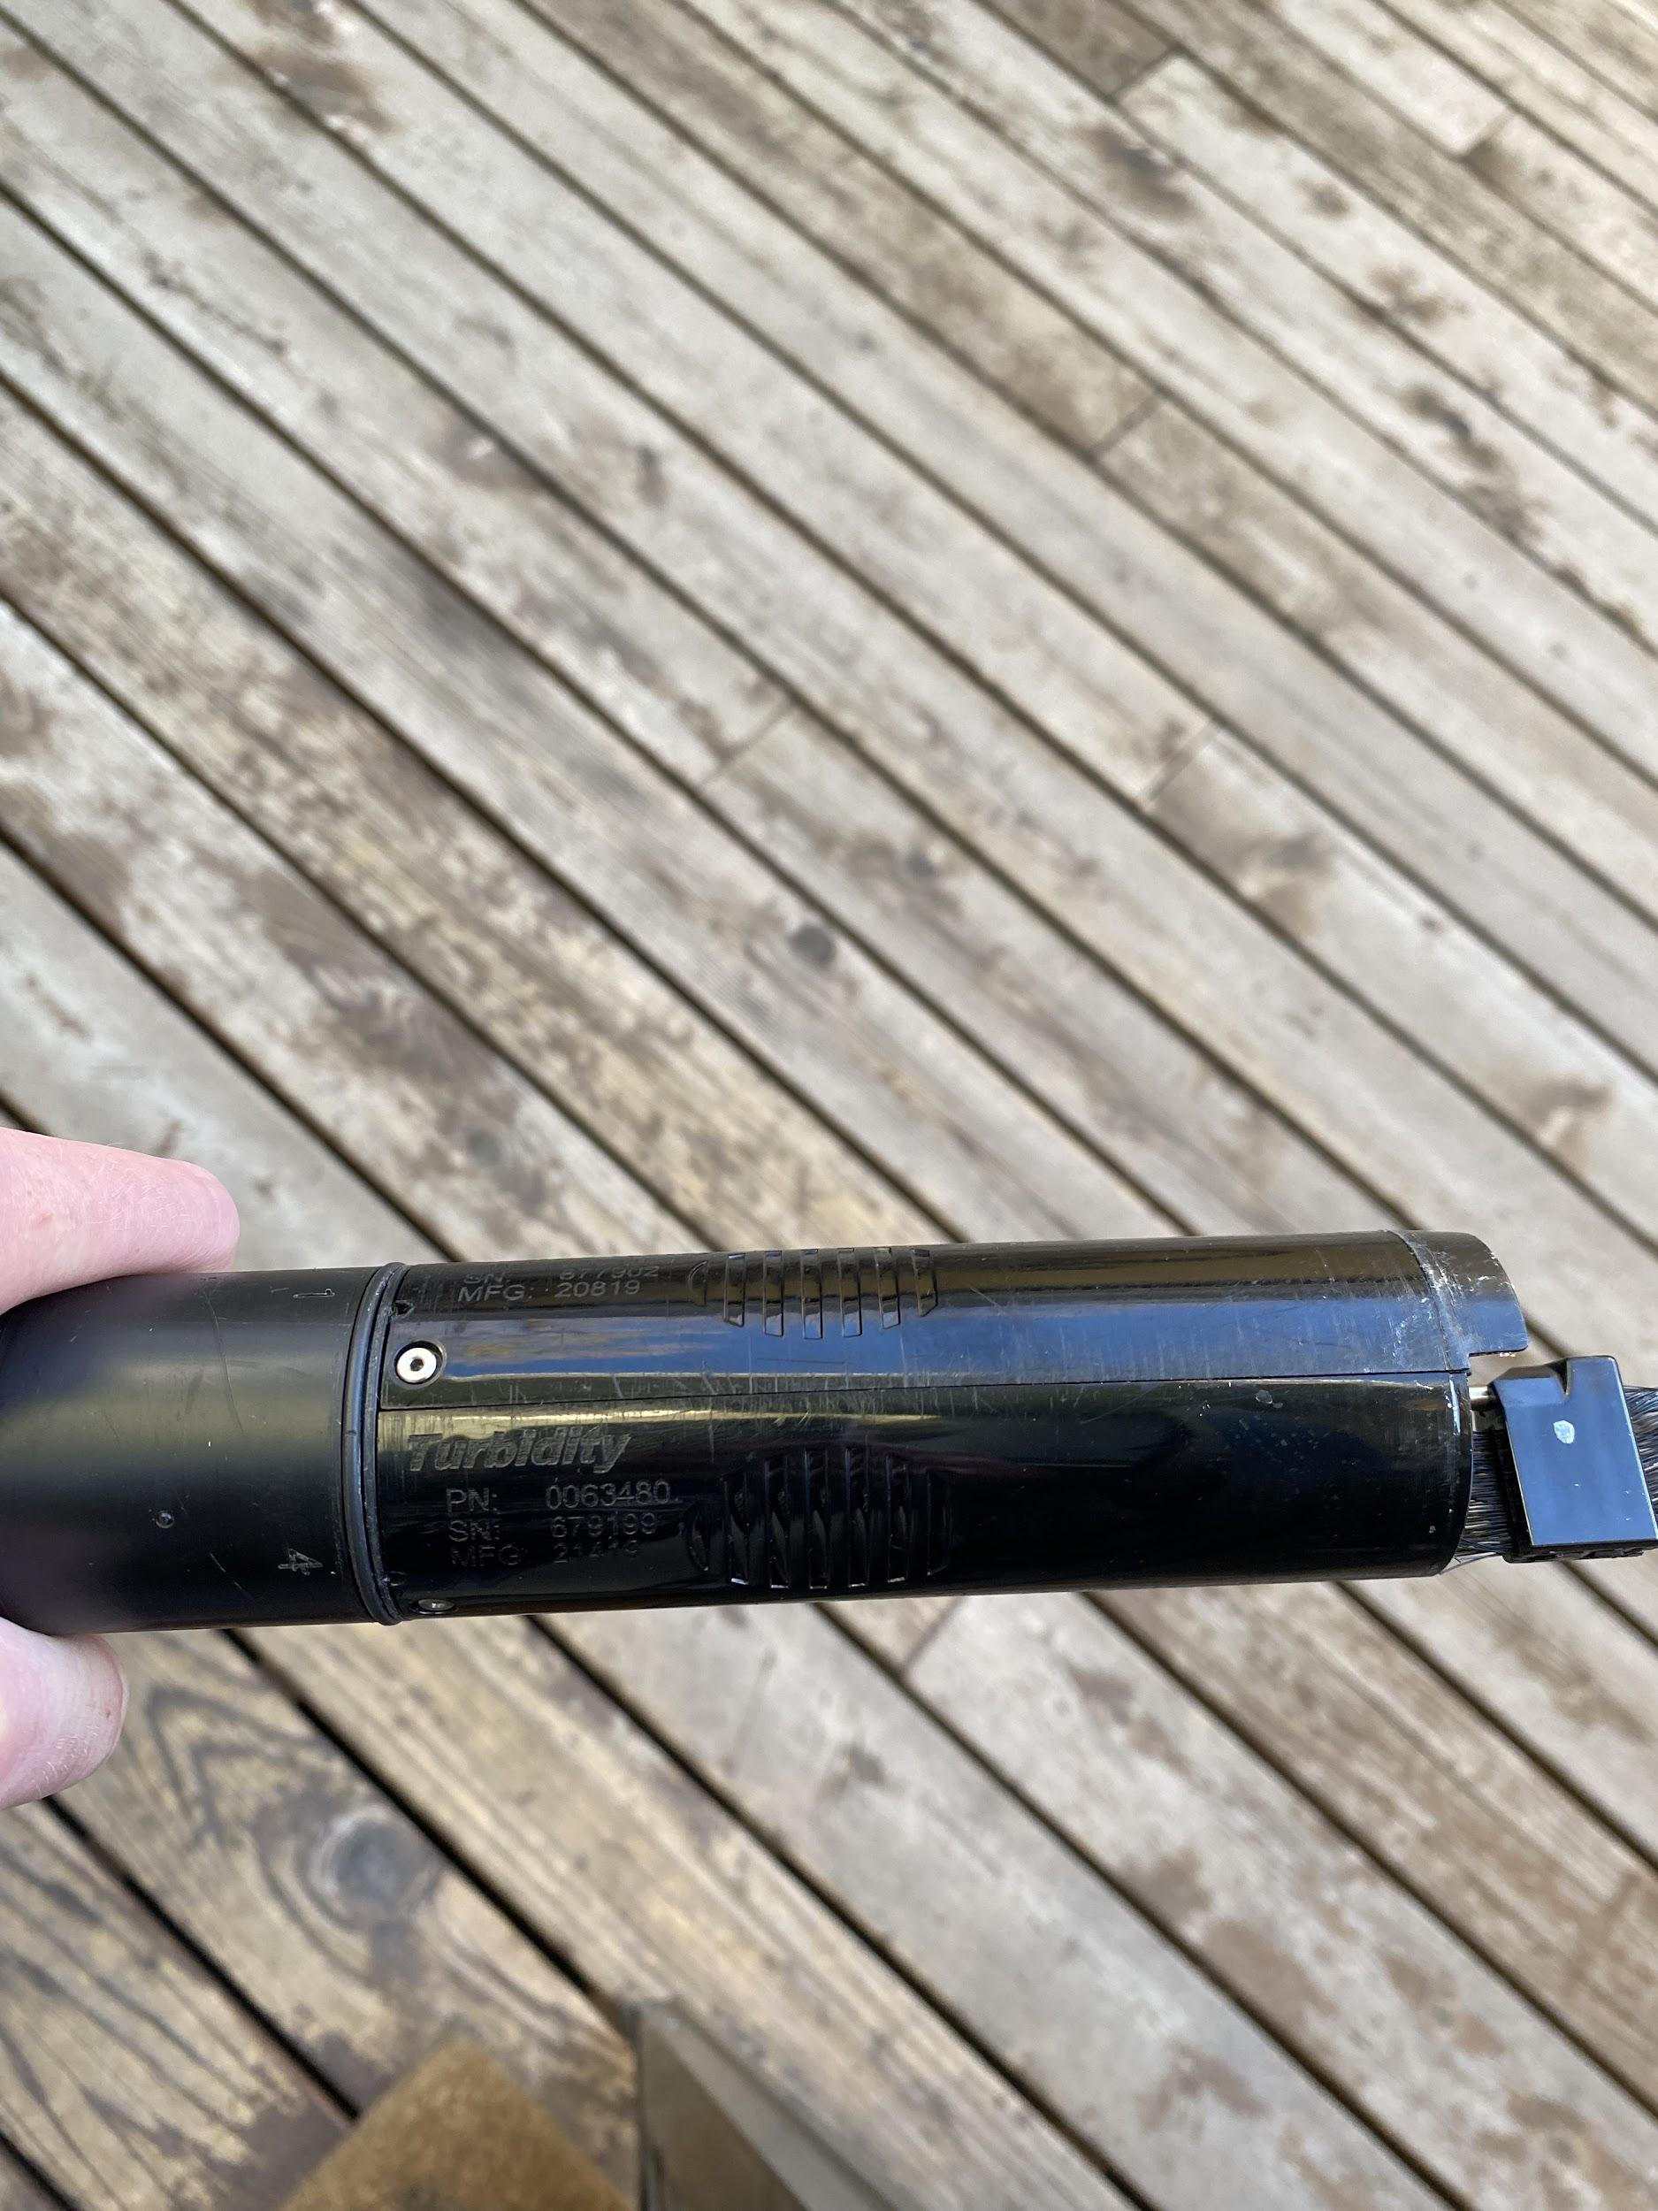

Figure 2. Turbidity Sensor on an AquaTroll Sonde.

AT 500 and AT 600 sonde can measure sediment levels in rivers with their turbidity sensors. Turbidity sensors take up one of the four spots in the housing of the sensor (Figure 2). Although In-Situ, Inc. recommends calibrations of the turbidity sensors as needed, the Ross Lab calibrates the turbidity sensor monthly. Calibrations ensure that the sensor can measure and report turbidity values accurately, even at extremely high or low NTUs. Calibrations can also repair errors in the turbidity sensor. Calibrations will be discussed more in the “Assessment” section.

Measuring turbidity in the field with both sondes is simple, as the sondes rely on Bluetooth technology to connect to Bluetooth-enabled laptops or smartphones and telemetry via VuLink continuous water monitoring dataloggers (which are also manufactured by In-Situ Inc.). When using a VuLink datalogger, the AT500 or AT600 must be connected to the VuLink physically with a cord, and the VuLink must be kept inside of a capped PVC pipe or similar housing structure on land. Data can be downloaded from the VuLink datalogger via Bluetooth. Data can also be downloaded directly from the AT500 or AT600 by connecting to its Bluetooth signals, but that requires pulling the sondes out of the water and holding them upright (sensor side up) to activate their Bluetooth signals. The tubing that houses the sondes must be perforated at the sonde to allow water to touch and flow through the sonde’s sensors.

To start collecting data, one must connect the sonde to their personal device via the VuSitu app. The VuSitu app connects to the sonde via Bluetooth with the “Connect” button. In that app, data collection can be commenced by the “Logging” tab, which allows the user to choose which parameters to measure, manually input the location of the sonde with GPS coordinates, choose the increments of data collection needed, choose a date range for downloading data, stop the current log, and more. Data can be downloaded in this tab from whichever logs the user needs with the “Download” tab. Once the data is downloaded, it can be sent to the user via text, email, and more. An example of a downloaded data log will be shown in the Assessment section.

**Assessment**

AquaTroll 500 and AquaTroll 600 Turbidity Calibrations

We will be calibrating the AT600’s turbidity sensor. FYI, calibrating the AT500 turbidity sensor has the exact same procedures and materials as this with the sole difference being the sensor calibrated.

<https://www.youtube.com/watch?v=Bnge9FDTFtQ>

This link includes In-Situ, Inc.’s calibration instructions. These are very general instructions; the video is meant to cover the basic procedures for calibrating all sensors. For turbidity, we need the sensor, the sensor’s blue cap. 10NTU solution, 100NTU solution, deionized (DI) water, and a Bluetooth enabled device with the VuSitu app.

**If you have any questions, watch the video from In-Situ (I watched it when I was learning to calibrate; it’s helpful) and ask your lab manager/professor/supervisor! Calibrating these sondes is simple, but it requires repetition and practice.**

The first thing you need to do is pull your sonde out of the water and disconnect the cable (if you’re using VuLink). Keep the sonde-side of the cable dry by wrapping it in plastic or gently putting it on the ground somewhere where it won’t get wet, stepped on, or filled with sediment. If you’re not using VuLink, then just take your sonde out of the water. Before messing with any of the sonde’s hardware, you must connect to the sonde itself (not the VuLink, the sonde!) and the current log (if a log is running) must be stopped. Once the log is stopped, you can enter Calibration Mode. Calibration Mode can be entered by selecting “Calibration” on the home screen once connected to the sonde. Each lab/employer/whoever is different, but in the Ross Lab, we do 2-point calibrations. That is why we need the 10NTU and 100NTU solutions. Download the data from the log you just stopped so that you can later compare it to the post-calibration data.

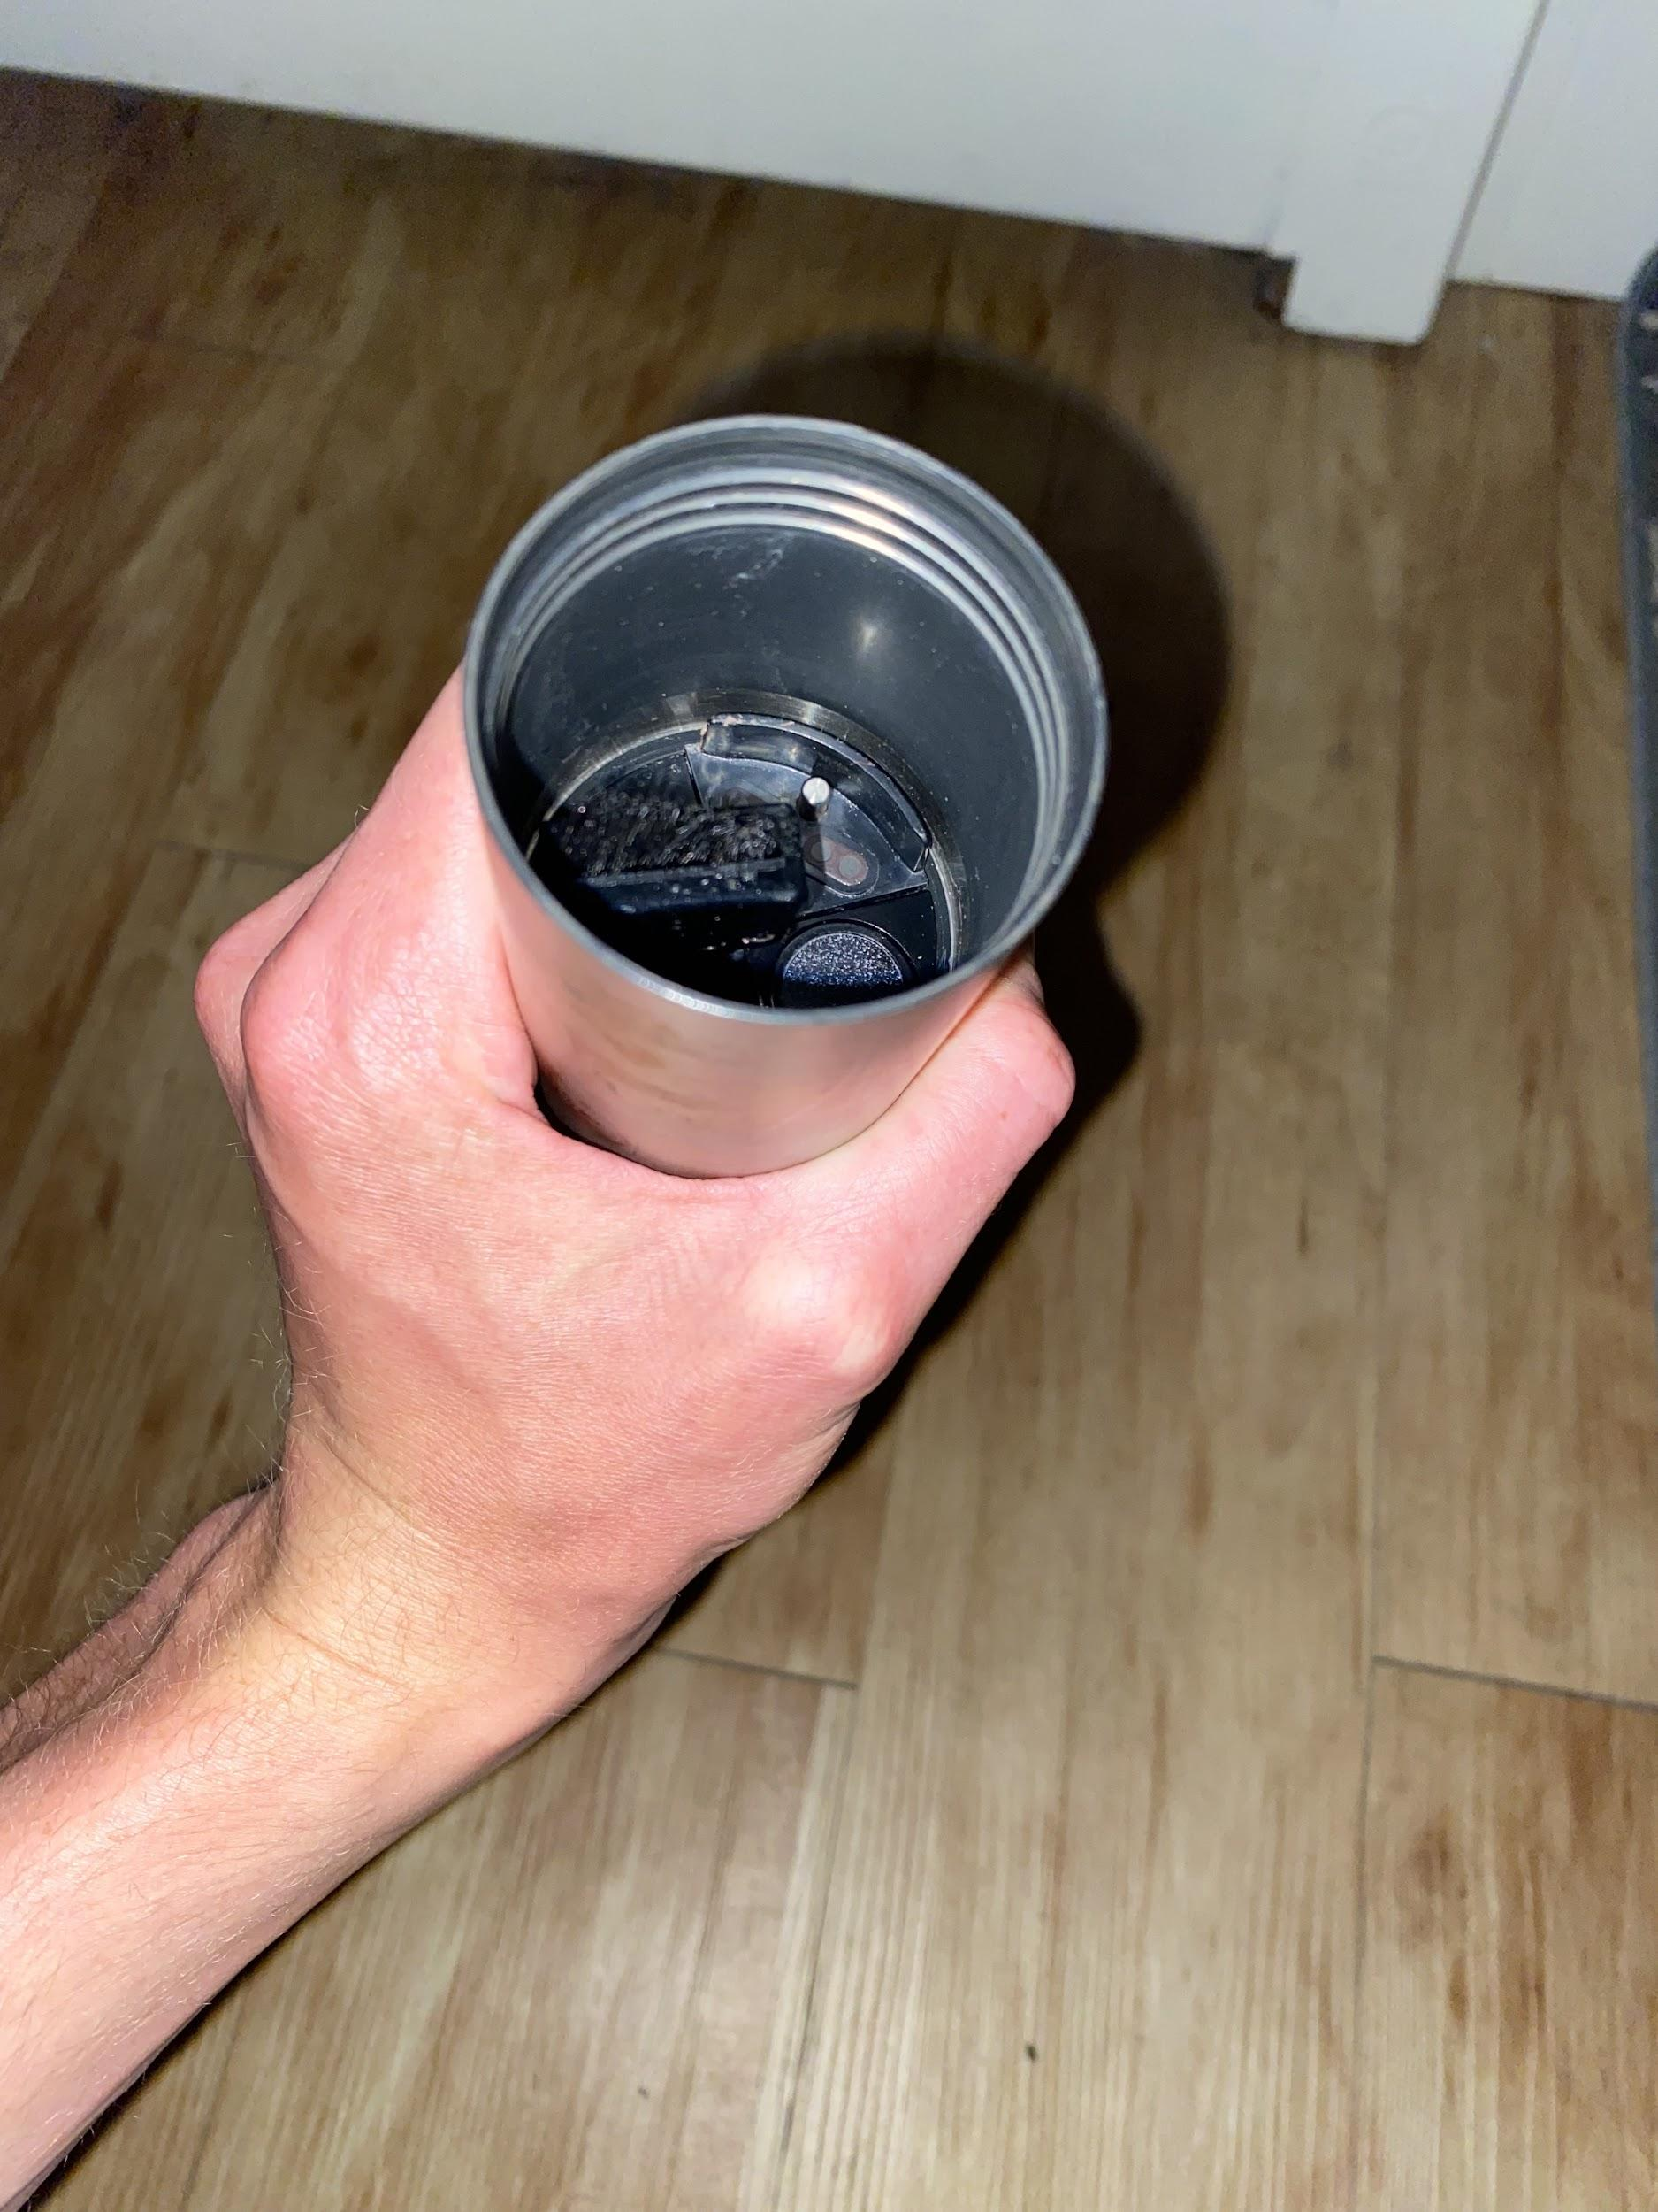

Figure 3. This is the most important figure so please look at it. This is what the restrictor and sensors look like with the restrictor turned over. This is what your restrictor and sensors **need** to look like when calibrating!

Once you are connected to the sonde in VuSitu and are in Calibration mode, remove the blue cap of the sensor, then unscrew the resistor (the silver tube that is perforated on one side). Flip the resistor over so that the perforated side is the side being screwed in. You should see now that the enclosed side of the resistor is surrounding the four sensors. Splash a small amount of DI water into the side with the enclosed sensors, put the blue cap on, then invert the sonde a few times to rinse the sensors and the inside of the resistor off. Open the resistor and pour the DI water into a pitcher/container. **It is important to rinse the sensors with DI water each time you commence a calibration and for each point of a calibration to prevent remnants of the previous solution from compromising the integrity of each point and parameter being calibrated.** **Do it! Don’t forget!**

Now that we have rinsed the sensors, we can start the calibration. Select “Turbidity”, then select “2-point calibration”. VuSitu will give you instructions (usually about four steps). We have already rinsed the sensors, so now we can splash a little bit of the 10NTU solution first into the resistor. Cap the resistor, then invert the sonde a few times to soak all of the sensors in the turbidity solution. Open the resistor and empty the small amount of 10NTU solution into the pitcher. Pour more 10NTU solution back into the resistor (about ¼ inch, enough to cover all the sensors but not so much that it is touching and covering the bottom half of the wiper brush) (Figure 3). Cap the resistor and press “Continue” on VuSitu; VuSitu will start the calibration. Wait for the different menus such as “Nominal” to appear and load, and let them load through and disappear. Once the “Stabilized” popup arrives and the screen turns green, that point of the calibration is done.

VuSitu will automatically move on to the next point. This point is the 100NTU calibration. Repeat the exact same steps as the 10NTU calibration, starting with emptying the 10NTU solution you just used into the waste container and rinsing the resistor/sensors with DI water. Once you reach the step in the calibration process where the “Stabilized” screen appears, you are done. VuSitu will ask you if you want to save the calibration, which you **should do**. Save it and send it to yourself however you like; it’s the same thing as downloading and sending the data from VuLink or the sonde, but it is a calibration report and not a log this time. Once you do that, you can exit calibration mode unless you want to calibrate different parameters. Navigate back to the main menu of your sonde then restart the log according to the criteria of your supervisor or lab manager.

Return to your sonde to check on it if any parameters look weird or if it is just time for your next calibration. Download your data as you have learned, and look at it. You can also set up real-time telemetry with the HydroVu website and check your data there after your calibration, but that is for another time and requires a lot of explaining. The link below is an example of part of the turbidity calibration I performed at the ELC site on 5/10.

Example files of the downloaded data from the ELC site and the calibration report will be included in the Canvas submission of this project. The calibration report is the “answer key” to this, but so is the data you later download when you go back to your sensor days/weeks/months later. The downloaded data from ELC is the sample data.

<https://share.icloud.com/photos/0c3ntu18ZjsVmvjiGmsZaoZZA> - This video just shows me doing the 10NTU calibration; it got windy right as I started 100NTU so that video just didn’t work out.

Credit to In-Situ Inc, Dr. Matthew Ross, and especially Katie Willi for demonstrating the sonde calibrations and for explaining the AT and VuLink equipment.

Appendix

In-Situ, Inc. AT 600 Manual <https://www.geotechenv.com/Manuals/In-Situ_Manuals/Aqua_TROLL_600_Manual.pdf>